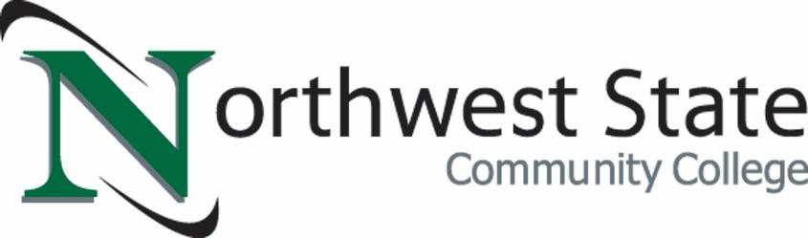

Senate Bill 126 Collin’s Law: Anti-Hazing Act

Northwest State Community College (NSCC) 2024 Report

Time Period: 2019 through 2024

Date of Report: December 16, 2024

NSCC prohibits hazing as defined in the Anti-Hazing Policy (3358: 14-5-23).

NSCC is committed to a safe and respectful campus environment that aligns with our institutional values. It is the College's belief that learning and working occurs in environments where learners, employees, and visitors feel safe, secure, and welcome.

The College acknowledges that as part of the higher education experience that learners and some employees participate in various extra- and co-curricular groups and organizations with different purposes and processes for affiliation. The College supports traditions within organizations that match the College’s core values. Hazing is antithetical to our institutional mission and has no place at NSCC.

The College recognizes that a student organization or group may belong to a national oversight organization that also holds students accountable to expectations and standards (e.g., the national organization for a local fraternity chapter). NSCC is committed to partnering with these outside affiliates to address hazing allegations and will communicate with them as appropriate.

NSCC is pleased to report that there have been *no hazing violations that have been reported for 2024 (as of 12/16/2024 at 1:45 PM) and for the preceding 7-year period (2017 through 2023)*.