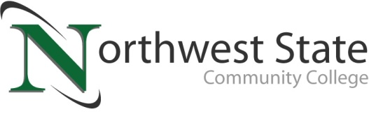

**DATE:** December 5, 2024

**CONTACT:** Jim Bellamy 419.267.1267 jbellamy@NorthwestState.edu

**NSCC FOUNDATION SEEKING NOMINATIONS FOR**

**2025 MAKING A DIFFERENCE AWARDS**

*Archbold, Ohio* – Each day, countless people make a positive impact on northwest Ohio, and the Northwest State Community College Foundation is offering an opportunity to recognize and celebrate those who have. The NSCC Foundation is accepting nominations for the 2025 “Making a Difference Award” in the categories of individual, business and organization.

“So much of the good work that’s done in our communities is appreciated, but not celebrated. It is the Foundation’s hope that recognizing the Making a Difference Award winners will inspire others to serve,” said Robbin Wilcox, Executive Foundation Director. “Residents throughout the six-county area are generous with their time and resources. Each year, the Foundation hears amazing stories of individuals, businesses and organizations that go above and beyond to make a difference in their community. We are currently seeking names of worthy award candidates again this year.”

The Making a Difference Awards will be presented during a special Green Carpet celebration on May 15, 2025. Nomination forms can be found online at **NorthwestState.edu/Making-a-Difference-Award** and are due to NSCC Foundation Office by January 3, 2025. For more information, contact Robbin Wilcox at 419.267.1460 or [**rwilcox@NorthwestState.edu**](mailto:rwilcox@NorthwestState.edu).

**Congratulations to our 2024 Recipients:**

Individual: Ed Kidston

Business: Daavlin

Organization: Symphony of Trees

###

*Northwest State Community College is an accredited two-year, state-assisted institution of higher education that has served northwest Ohio since 1969. Northwest State is committed to providing a quality, affordable education with personal attention and small class sizes. The College offers associate degrees with numerous transfer options, short-term certificate programs, and workforce training programs designed to meet the needs of local businesses and industries. For more information, visit NorthwestState.edu or call 419.267.5511.*