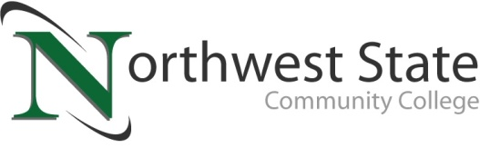

**DATE:** November 19, 2024

**CONTACT:** Jim Bellamy 419.267.1267 jbellamy@NorthwestState.edu

**NORTHWEST STATE COMMUNITY COLLEGE HONORed AREA VETERANS  
WITH FREE VETERANS LUNCHEON**

*Archbold, Ohio* – The Northwest State Community College Auditorium was near capacity as the College welcomed NSCC employee and student veterans, community veterans and their families, elected officials and other distinguished guests for a complimentary Veterans Luncheon on Thursday, November 7th. The luncheon served to recognize and honor veterans for their valued service to our nation.

NSCC President Dr. Todd Hernandez, a US Navy veteran, opened the event with welcoming remarks. As a highlight, Keynote speaker Chief Master Sergeant Michael Haas from the Air Force, 180th Division (Retired) shared some memorable experiences from his time of service. Kerry Patrick Clark provided the musical entertainment during the event, to the delight of the audience.

“It is our privilege to pay tribute and give thanks to those who bravely serve, or have served, in the United States military,” said Robbin Wilcox, Executive Foundation Director at Northwest State. “NSCC is dedicated to serving the veteran community, and this luncheon is one shining example of that service.”

NSCC currently has approximately 120 student-veterans pursuing coursework, credentialing, certificates and/or associate degrees. For more information on veteran services available at Northwest State Community College, please call the Registrar’s Office at 419.267.1395 or visit them online at **NorthwestState.edu/veteran**.

###

*Northwest State Community College is an accredited two-year, state-assisted institution of higher education that has served northwest Ohio since 1969. Northwest State is committed to providing a quality, affordable education with personal attention and small class sizes. The College offers associate degrees with numerous transfer options, short-term certificate programs, and workforce training programs designed to meet the needs of local businesses and industries. For more information, visit NorthwestState.edu or call 419.267.5511.*

***PHOTO GALLERY:*** [***https://northweststate.smugmug.com/20241107-Veterans-Day-luncheon-MEDIA***](https://northweststate.smugmug.com/20241107-Veterans-Day-luncheon-MEDIA)