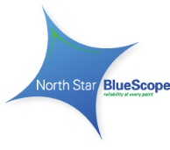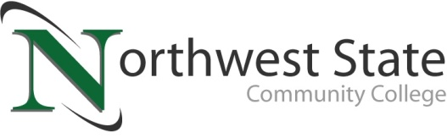

**Date:** May 19, 2025

**NORTHWEST STATE ANNOUNCES EDUCATIONAL PARTNERSHIP  
WITH NORTH STAR BLUESCOPE STEEL**

*ARCHBOLD, OHIO –* Northwest State Community College is pleased to announce a strategic partnership with North Star BlueScope Steel that will expand educational opportunities for high school students in Fulton County and the surrounding area. Beginning this fall, Northwest State will offer on-site college courses at the North Star BlueScope facility, specifically designed for high school students interested in pursuing careers in engineering or industrial maintenance.

This dual enrollment initiative provides students with a unique hands-on learning experience in a real-world industrial setting, while earning college credit toward a clearly defined career pathway. The curriculum has been developed to align with workforce needs and prepare students for high-demand, high-wage careers in our region.

“We are working closely with North Star, and NSCC faculty and administration, to ensure the program complements existing high school schedules and supports student success. Our goal is to coordinate with high school counselors immediately so that interested students can enroll for a fall 2025 start,” noted Brittany Thompson, Executive Director of Enrollment Management at Northwest State.

“Developing a high-quality workforce is critical for North Star. And Northwest State supports affordable training in important skills like electronic controls, advanced fluids, industrial maintenance and machining, as well as cyber security, safety and sustainability,” said North Star BlueScope Steel President Conrad Winkler. “This partnership is really exciting because it has the potential to unlock real career paths for local young people; and we think that ‘unlock’ benefits all of us. Great training opens the door to great careers that create strength in our communities and for North Star.”

For additional information on this exciting collaboration, please contact NSCC Admissions at 419.267.1320 or **admissions@NorthwestState.edu**.

###

***About Northwest State Community College***

*Northwest State Community College is an accredited two-year, state-assisted institution of higher education that has served northwest Ohio since 1969. Northwest State is committed to providing a quality, affordable education with personal attention and small class sizes. The College offers associate degrees with numerous transfer options, short-term certificate programs, and workforce training programs designed to meet the needs of local businesses and industries. For more information, visit NorthwestState.edu or call 419.267.5511.*

***Media contact for Northwest State:*** *Jim Bellamy, 419.267.1267* [*jbellamy@NorthwestState.edu*](mailto:jbellamy@NorthwestState.edu)

***About North Star BlueScope Steel***

*North Star BlueScope Steel is the preferred supplier of high-quality steel products (hot-rolled coil) and leading service for*

*customers in critical industries, including automotive, construction, manufacturing and agriculture. Working together, the*

*North Star team operates the lowest carbon-emitting hot-rolled steel coil operation in the U.S., while delivering significant*

*water conservation and reduced waste-to-landfill programs. With more than 575 team members, North Star also is an*

*important corporate citizen in Fulton County, Ohio, promoting volunteerism, community service and sponsorship as core*

*attributes of its organizational culture.*

***Media Contact for North Star:*** *Mark Hein, Head of Corporate Affairs +1 (816) 639-5821 | mark.hein@bluescopesteel.com*