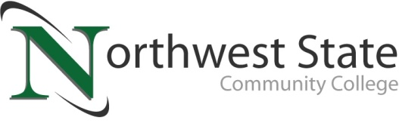

**DATE:** May 3, 2024

**CONTACT:** Jim Bellamy | 419.267.1267 | jbellamy@NorthwestState.edu

**NORTHWEST STATE COMMUNITY COLLEGE PHLEBOTOMY AND MEDICAL ASSISTING  
GRADUATES CELEBRATED AT PINNING CEREMONY**

*ARCHBOLD, OHIO –* Three students from the medical assisting program, along with twelve students from the phlebotomy technician program were recognized at a special ceremony held earlier this week at Northwest State Community College. Both options lead to entry-level positions in the health care field, and students earning the phlebotomy technician certificate may choose to continue their education for an associate degree in medical assisting.

**Medical Assisting student recognized:**

Sarah Breece (Hamler), Jessie Lake (Delta), and Alethia Stimpfle (Montpelier)

**Phlebotomy students recognized:**

Katelyn Carter (Napoleon), Hadlee Henderson (Delta), Sheyann Klingensmith (Hudson, MI), Kyleigh Logan (Cecil), Makena Mendoza (Defiance), Brandy Mitchum (Waterville), Karsen Pursel (Archbold), Logan Seibert (Oakwood), Reed Silguero (Stryker), Skye Swalley (Bryan), Caitlin Walls (Whitehouse), and Selene Yeager (Wauseon)

###

*Northwest State Community College is an accredited two-year, state-assisted institution of higher education that has served northwest Ohio since 1969. Northwest State is committed to providing a quality, affordable education with personal attention and small class sizes. The College offers associate degrees with numerous transfer options, short-term certificate programs, and workforce training programs designed to meet the needs of local businesses and industries. For more information, visit NorthwestState.edu or call 419.267.5511.*

**The media photo gallery is available at:**

**https://northweststate.smugmug.com/20240501-Medical-Assisting-Phlebotomy-pinning-MEDIA**