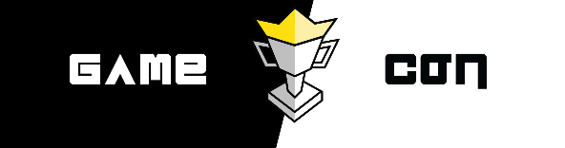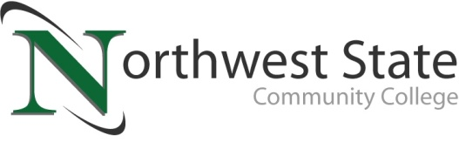

**DATE:** April 30, 2025

**CONTACT:** Jim Bellamy 419.267.1267 [jbellamy@NorthwestState.edu](mailto:jbellamy@NorthwestState.edu)

or Dylan Guthrie - DGuthrie@NorthwestState.edu

**NORTHWEST STATE’s gaming and pop culture convention**

**‘game con’ to return in june**

*Archbold, Ohio* – Northwest State Community College is bringing back Game Con, “the premier pop culture convention,” on Saturday, June 14th from 10:00 a.m. to 6:00 p.m. The convention is run by Northwest State and NSCC Thunder, the college’s official Esports team. **The event is free to attend, and all ages are welcome.**

Game Con will feature many events and competitions, some returning and some new. They include a 100-player *Super Smash Bros. Ultimate* Tournament with a $600 prize pool, a Cosplay Contest with a $500 prize pool, a Yu-Gi-Oh Card Game Tournament with a Yu-Gi-Oh related prizes, and other open activities available to all attendees.

**PLENTY OF ACTIVITIES AVAILABLE…**

Some of the open activities scheduled for Game Con include:

* Artists, Vendors, and Authors
* Various Panels
* *Dungeons & Dragons* Character Creation Workshop
* Open Console Play with Nintendo Switches, PlayStations, and Many More Consoles
* Virtual Reality (VR) Experiences
* Food Trucks, Open *LEGO* Build Stations, and More!

**THANKS TO THE EVENT SPONSORS…**

Event sponsors currently include Worthington Industries, Sauder Manufacturing, Bryan GameStop, and N.W.O. Gamers.

**ADDITIONAL INFORMATION…**

Additional information, including pre-registration links, photos, etc., are available at **NorthwestState.edu/GameCon**. Follow NSCC Thunder on social media at **Instagram.com/NSCCThunder**, **Twitter.com/NSCCThunder**,and **Facebook.com/NSCCThunder** for more information about vendors, events, and other Game Con news.

###

*Northwest State Community College is an accredited two-year, state-assisted institution of higher education that has served northwest Ohio since 1969. Northwest State is committed to providing a quality, affordable education with personal attention and small class sizes. The College offers associate degrees with numerous transfer options, short-term certificate programs, and workforce training programs designed to meet the needs of local businesses and industries. For more information, visit NorthwestState.edu or call 419.267.5511.*