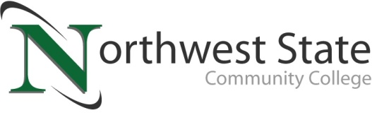

**DATE:** April 28, 2025

**CONTACT:** Jim Bellamy 419.267.1267 jbellamy@NorthwestState.edu

**NORTHWEST STATE COMMUNITY COLLEGE enrollment and retention highlighted at board of trustees meeting**

*Archbold, Ohio* – The Northwest State Community College Board of Trustees met in regular session on Friday, April 25th at the Archbold campus. As part of the meeting’s agenda, the Board heard presentations from Cabinet members. One such presentation was from Cassie Rickenberg, NSCC Vice President for Enrollment Management & Student Affairs. Rickenberg noted that for the Summer 2025 semester (48 days until start), there is a 10% increase in overall student count versus last summer, including a 13% increase in returning learners, and a 31% increase in guest learners. For the Fall 2025 semester (120 days until start), there is a 9% increase in overall student count versus last fall, including a 27% increase in new learners, and a 20% increase in returning learners.

"Enrollment growth is not the result of one initiative or department," said Rickenberg. "It’s the result of a unified, campus-wide commitment to making education accessible, flexible, and responsive to the needs of our learners. We are proud of the work our teams have done at Northwest State to make this possible."

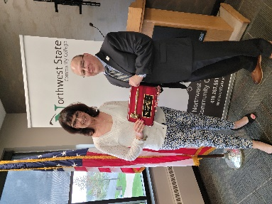**ADDITIONAL HIGHLIGHTS**

At the conclusion of the meeting, NSCC President Dr. Todd Hernandez presented Sandra Barber (Fulton County) an “Extraordinary Service Award” for her dedicated service as Chair for the Board of Trustees from February 2024 to February 2025. Of the award, Dr. Hernandez noted his gratitude and appreciation: “Trustee Barber exemplifies what being a Board of Trustees member is all about. She is passionate about every aspect of Northwest State, including our mission, our faculty and staff, and without question, our learners.”

**In other Board action:**

* Approved the promotion of James Smith to Training & Equipment (Manufacturing) Manager, and Krista Maassel to Cook.
* Approved an amended policy for admission to the College (adding language on students to include College Credit Plus (CCP) and non-CCP high school students.
* Approved miscellaneous employment contracts.
* Approved three resignations.

###

*Northwest State Community College is an accredited two-year, state-assisted institution of higher education that has served northwest Ohio since 1969. Northwest State is committed to providing a quality, affordable education with personal attention and small class sizes. The College offers associate degrees with numerous transfer options, short-term certificate programs, and workforce training programs designed to meet the needs of local businesses and industries. For more information, visit NorthwestState.edu or call 419.267.5511.*