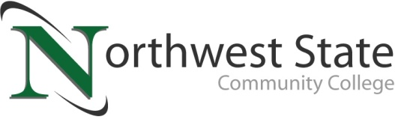

**DATE:** April 25, 2025

**CONTACT:** Jim Bellamy | 419.267.1267 | jbellamy@NorthwestState.edu

**Northwest state community college SPRING COMMENCEMENT**

*Saturday, May 10, 2025 at 2:00 p.m. at Founder’s Hall (Archbold)*

*Archbold, Ohio –*

**Who:** Graduates, family members, faculty and staff of Northwest State Community College will attend the Spring Commencement Ceremony. Media are invited to cover the event.

**What:** NSCC President Dr. Todd Hernandez will welcome the spring 2025 Commencement of Northwest State Community College. Ann Ebbert (President/CEO of Cherry Street Mission) will offer the Commencement address. 224 students will be receiving a total of 228 degrees and/or certificates.

**When:** Saturday, May 10, 2025 at 2:00 p.m.

**Location: Founder’s Hall (Archbold)**

Event is also available on the College’s YouTube channel – **YouTube.com/user/NorthwestStateCC**

**facts: 224 Graduates will be recognized for their achievements.** Ann Ebbert (President/CEO of Cherry Street Mission) will offer the Commencement address. **Of note, 14 College Credit Plus (CCP) students will be earning their degrees prior to High School Graduations in the region! The event will be held in-person at Founder’s Hall in Archbold. Those unable to attend can watch the ceremony on the College’s official YouTube page, YouTube.com/user/NorthwestStateCC.**

###

*Northwest State Community College is an accredited two-year, state-assisted institution of higher education that has served northwest Ohio since 1969. Northwest State is committed to providing a quality, affordable education with personal attention and small class sizes. The College offers associate degrees with numerous transfer options, short-term certificate programs, and workforce training programs designed to meet the needs of local businesses and industries. For more information, visit NorthwestState.edu or call 419.267.5511.*