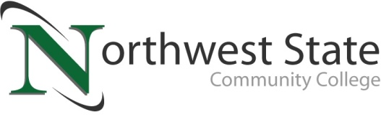

**Date:** April 18, 2025

**Contact:** Jim Bellamy | 419.267.1267 | jbellamy@northweststate.edu

**NORTHWEST STATE TO HOST SUMMER CAMPS FOR STUDENTS OF ALL AGES!**

*Archbold, Ohio –* Northwest State Community College will host a series of hands-on summer STEM camps for learners of all ages, beginning on June 9 with *Tinker Camp*. The camp season will wrap up on July 16. This year’s summer camp subjects include many of Northwest State’s academic divisions, including Custom Training Solutions (CTS), Arts & Sciences and Nursing & Allied Health, and Business & Public Service. All camps will be hosted at the Archbold campus, and campers can expect fun, hands-on learning activities as part of their action-packed camps.

For all grade ranges listed below, it is the grade students finished in 2025 unless the camp specifies otherwise.  
  
**JUNE CAMPS**Tinker Camp (Grades 1-2), Jr. Brick Builders (Grades 1-2), Junk Bot Builder Camp (Grades 5-8), Master of the LEGO Brick (Grades 5-8), Babysitting Basics (Ages 12 & older), First Aid & CPR Camp (Grades 5-12), SPIKE Robotics (Grades 5-7).  
  
**JULY CAMPS**Space Camp Adventure (Grades 5-9), LEGO Brick Builders (Grades 3-4), RoboMania: Where fun meets Future Tech (Grades 3-4), Wild About Animal Art (Grades 4-8).

Dr. Todd Hernandez, President at Northwest State, noted “The NSCC summer camps mainly focused on STEM and advanced manufacturing in recent years, but our faculty across campus have really brought some innovative camp ideas to fruition these past few years, and we’re excited to see campers of all ages at the College.”

For a complete listing of the Northwest State summer camps, including dates, ages, fees and registration information, please visit **NorthwestState.edu/Camps**, or contact Jani Tisovic at the College by phone at 419.267.1381 or by email **SummerCamps@NorthwestState.edu**.

###

*Northwest State Community College is an accredited two-year, state-assisted institution of higher education that has served northwest Ohio since 1969. Northwest State is committed to providing a quality, affordable education with personal attention and small class sizes. The College offers associate degrees with numerous transfer options, short-term certificate programs, and workforce training programs designed to meet the needs of local businesses and industries. For more information, visit NorthwestState.edu or call 419.267.5511.*