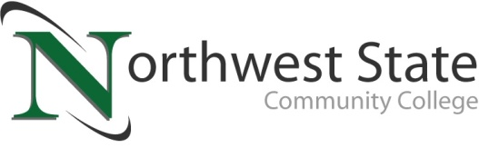

**DATE:** April 17, 2025

**CONTACT:** Jim Bellamy 419.267.1267 jbellamy@NorthwestState.edu

**northwest state community college-led team earns 7th place finish IN championship round of state first robotics competition**

*Archbold, Ohio* – The Northwest State Community College FIRST Robotics high school team 6181 (Cryptic Cyborgs) competed at the 2025 Buckeye Regional tournament held at Cleveland State University – Wolstein Center, April 3 through April 5, 2025. Teams from Ohio, New York and Pennsylvania, as well as international teams from the Dominican Republic and Turkey competed at the event. The Northwest State Community College team members are from local high schools in northwest Ohio, including Ayersville, Central Local (Fairview), Delta, Liberty Center, Napoleon, Wauseon, and Four County Career Center.

**COMPETITION BREAKDOWN**

The NSCC Cryptic Cyborgs went 7-2 in qualifying rounds on Friday and Saturday morning, which earned them a 10th place finish out of 56 teams in the qualifying rounds. The Cyborgs bowed out in the championship round double-elimination tournament on Saturday afternoon, finishing in 7th place overall.

**QUOTABLE**

“Team 6181 would like to thank the parents of the students on the team, and our generous sponsors. We are pleased with a 7th place finish, and this event provided a great learning experience for our team. The combination of hands-on learning, the excitement of competition, and the fun overall experience made it an unforgettable weekend,” said Jim Drewes, Vice President for Workforce Development at Northwest State, and the advisor for the FIRST Robotics program at Northwest State. Drewes noted that the team will participate in off-season robotics competitions in Ohio and Indiana as well.

###

*Northwest State Community College is an accredited two-year, state-assisted institution of higher education that has served northwest Ohio since 1969. Northwest State is committed to providing a quality, affordable education with personal attention and small class sizes. The College offers associate degrees with numerous transfer options, short-term certificate programs, and workforce training programs designed to meet the needs of local businesses and industries. For more information, visit NorthwestState.edu or call 419.267.5511.*

