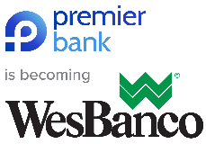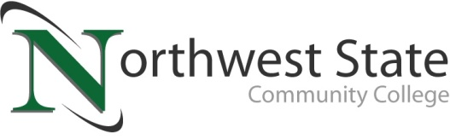

**DATE:** April 15, 2025  
**CONTACT:** Jim Bellamy 419.267.1267 jbellamy@NorthwestState.edu

**NORTHWEST STATE TO PRESENT 11TH ANNUAL  
ENTREPRENEURSHIP FORUM ON THURSDAY, MAY 8  
**OVER $2,000 TO BE AWARDED\*\***

*Archbold, Ohio –* Northwest State Community College celebrates the spirit of entrepreneurship and the power of small businesses in hosting its 11th annual Entrepreneurship Forum on **Thursday, May 8th from 4:00-6:00 p.m.** in the Voinovich Auditorium. This FREE event is open to all residents of Defiance, Fulton, Henry, Paulding and Williams Counties with a business idea and want help in moving it forward.

**VALUABLE EXPERIENCES**

The 2025 Entrepreneurship Forum provides budding entrepreneurs the opportunity to **present their ideas** to a panel of experts from the region, and to **network with those experts** – both very valuable experiences. Local economic development directors and lenders from the five-county area will make up the advisory panel.

**Thanks to grant funding by the Everyday Entrepreneurship Fund, and our friends at Premier Bank, EVERY presenter will be able to receive (at minimum) funding for the registration fee to start their business in Ohio!**

**“SMALL BUSINESS IS VITAL”**

“Northwest State, the Small Business Development Center, and economic development are joining forces to invigorate small business growth in Northwest Ohio. Small business is vital to our communities. We need entrepreneurs to keep our economy strong,” said Lisa Becher, business faculty at Northwest State. Becher is also the State of Ohio Small Business Development Center Consultant in NW Ohio and a local business owner. She has created a “semi-Shark Tank style” event that helps aspiring business owners by removing barriers to market. “The forum was created to break down barriers and move entrepreneurs forward, helping them with an idea. Many people just don't know what to do next and how to get started. This is a great opportunity to discuss your idea, get a start on your project and work with economic development and area lenders. Past presenters have found this Forum experience invaluable, for networking, funding opportunities, and helping move their projects forward. We are excited to work with the Everyday Entrepreneurship Fund and Premier Bank to offer entrepreneurs additional financial resources in helping to build our communities!” Becher continued.

**HOW TO REGISTER**

People can register for the Entrepreneurship Forum by emailing Lisa Becher at **lbecher@NorthwestState.edu** or **NWOhioSBDC@gmail.com**. Registration is required for everyone and is free of charge. Space is limited, so early registration is strongly encouraged. “Free consultation services will be provided by the Small Business Development Center,” Becher said. Of note, a presentation template is required, and is available by contacting Lisa Becher at the email addresses above.

###

*Northwest State Community College is an accredited two-year, state-assisted institution of higher education that has served northwest Ohio since 1969. Northwest State is committed to providing a quality, affordable education with personal attention and small class sizes. The College offers associate degrees with numerous transfer options, short-term certificate programs, and workforce training programs designed to meet the needs of local businesses and industries. For more information, visit NorthwestState.edu or call 419.267.5511.*