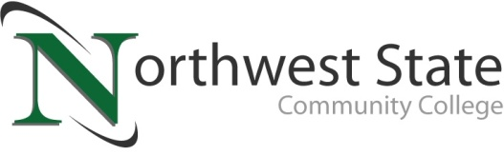

**Date:** April 14, 2025

**Contact:** Jim Bellamy | 419.267.1267 | jbellamy@northweststate.edu

**NSCC FOUNDATION AWARDS OVER $900,000 in FOUNDATION scholarships**

*Archbold, Ohio –* On Thursday, April 10th, the Northwest State Community College Foundation proudly awarded a record 440 scholarships worth in excess of $900,000 to students from the region. The event theme was “Unlock Students’ Possibilities,” and it spotlighted scholarship recipients, donors and the community as well.

“We were blessed to hold another amazing Scholarship Awards event for our community,” said Robbin Wilcox, Executive Director of Development & the NSCC Foundation. “We are so proud of our students’ accomplishments, and we are grateful for the generosity of our donors – they help unlock students’ possibilities,” Wilcox noted.

The event kicked off with opening remarks by NSCC Executive Vice President and Chief of Staff Dr. Albert Lewis, Jr, who shared a personal story about the importance of education, thanked the donors and congratulated the students for their accomplishments. Jackie Schlachter-Flores (HR Director for Wieland Chase, and 1995 NSCC alum), provided the Donor and Foundation Board perspective.

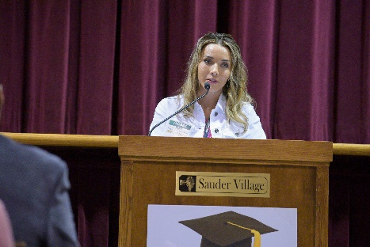

**AMAZING STUDENT STORY**

Tiffany Kern (Business major) provided the student perspective, sharing her perseverance and overcoming seemingly impossible obstacles, including growing up in a household where drugs were used, and going through her own detoxing.“Deep down inside, I knew that wasn’t the real me. I knew that I had always envisioned better for my life. I did NOT want to spend my life chasing drugs,” Kern said. Today, Kern is 16 years clean and sober, and she is the recipient of the George Isaac Business Scholarship.

**ABOUT THE NSCC FOUNDATION**

The NSCC Foundation was established in 1978 to provide support for the students, people and programs of NSCC. For over 40 years, the Foundation has remained true to its mission to enhance, expand and sustain Northwest State so that NSCC can continue to fulfill its mission of creating opportunities for transformational learning. The NSCC Foundation works diligently to raise much-needed funds for educational opportunities that directly and indirectly impact students. “The NSCC Foundation continues to work hard each year to increase funding to support our students through both scholarships and efforts to provide state of the art training equipment,” noted Wilcox. She added, “The NSCC Foundation is not only giving over $900,000 in scholarship dollars this year, but they are also helping the College to develop and expand programs that will help both students and our business partners for generations to come.” Additional information about the NSCC Foundation is available at **NorthwestState.edu/foundation**.

###

*Northwest State Community College is an accredited two-year, state-assisted institution of higher education that has served northwest Ohio since 1969. Northwest State is committed to providing a quality, affordable education with personal attention and small class sizes. The College offers associate degrees with numerous transfer options, short-term certificate programs, and workforce training programs designed to meet the needs of local businesses and industries. For more information, visit NorthwestState.edu or call 419.267.5511.*

***PLEASE NOTE: SELECT MEDIA IMAGES FROM THE EVENT ARE AVAILABLE AT***

***https://northweststate.smugmug.com/20250410-Scholarship-Awards-Reception-MEDIA***