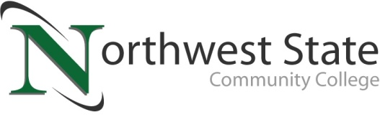

**DATE:** March 12, 2025

**CONTACT:** Jim Bellamy 419.267.1267 jbellamy@NorthwestState.edu

**NORTHWEST STATE COMMUNITY COLLEGE CENTER FOR LIFELONG LEARNING  
TO WELCOME AMATEUR AUTHOR E.J. WESTHOVEN**

*Archbold, Ohio* – The NSCC Center for Lifelong Learning is proud to present “So, you want to be an author? Things I’ve learned in my writing journey,” featuring amateur author E.J. Westhoven. The event will be held on Friday, April 4th at the Northwest State Community College Archbold Campus, room C211, from 9:00 a.m. to noon. The cost to attend the event is $13.00.

**ABOUT E.J. WESTHOVEN**

E.J. began writing during his time off work from some major surgery. After writing a fanfic (a story based on another story), he got an idea for an original story. Starting with a “Point A” and “Point B,” the story soon blossomed into a book. Then came the idea for a sequel, which was followed up with a prequel. Along with his self-published trilogy, E.J. has recently published his fourth book, “All These Years,” about a man who finds out he has a daughter who’s about to turn eighteen years old. E.J. will be discussing his journey and experiences on how he came to write his books.

**RESERVE YOUR SPOT TODAY!**

Register by Monday, March 31st to reserve your spot. A full hot breakfast begins at 9:00 a.m., followed by our guest speaker until approximately 11:30 a.m. To sign up today, call Deb Wikstrom at 419.267.5511, or email **lifelong@NorthwestState.edu**. For more information on the CFLL, and other upcoming programs, please visit **NorthwestState.edu/lifelong-learning**.

###

*Northwest State Community College is an accredited two-year, state-assisted institution of higher education that has served northwest Ohio since 1969. Northwest State is committed to providing a quality, affordable education with personal attention and small class sizes. The College offers associate degrees with numerous transfer options, short-term certificate programs, and workforce training programs designed to meet the needs of local businesses and industries. For more information, visit NorthwestState.edu or call 419.267.5511.*