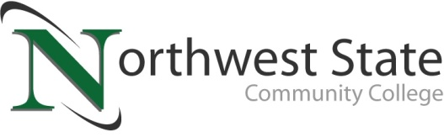

**DATE:** February 25, 2025

**CONTACT:** Jim Bellamy 419.267.1267 jbellamy@NorthwestState.edu

**NORTHWEST STATE COMMUNITY COLLEGE BOARD OF TRUSTEES**

**ELECTS NEW OFFICERS**

*Archbold, Ohio* – The Northwest State Community College Board of Trustees met in regular session on Friday, February 21st at the Archbold campus. As part of the meeting’s agenda, the Board elected its new Chair, Vice Chair and Second Vice Chair for the period of February 2025 to February 2026. Katrina DeGroff (Fulton County) was elected Chair, Mickey Schwarzbek (Defiance County) was elected Vice Chair, and Joel Miller (Henry County) was elected as Second Vice Chair by the Board. NSCC President Dr. Todd Hernandez offered remarks of gratitude for Sandra Barber, who served as Chair for the 2024-2025 period, for her ongoing dedication and years of service to the College.

**ADDITIONAL HIGHLIGHTS**

Prior to electing its new officers for 2025-2026, the Board reviewed and approved the 2024-2025 revised budget. The revised budget is $44,314,130, which is a net adjustment of ($767,235). Sandra Barber and John Bridenbaugh were appointed as Delegate and Alternate from the Board to serve on the governing board of the Ohio Association of Community Colleges (OACC) for the period of February 2025 through February 2026. Finally, the Board confirmed the following upcoming meeting dates: Friday, April 25; Thursday, June 26; Friday, August 15; Friday, October 17; Friday, December 12; and Friday, February 20 (2026).

**In other Board action:**

* Approved the employment of Vena Valdez-Chowdhury as Administrative Assistant-Community & Workforce Development, Katherine Murphy as Faculty-Nursing, Jesse Schumacher as Faculty-Business (Accounting), and Breanna Sancrant as Administrative Assistant-Nursing & Allied Health.
* Approved the 2025-2026 student fees.
* Approved Workplace Violence Policy.
* Rescinded Gender Inclusive Restroom Facilities policy 14-3-33.
* Approved expansion of authority of the NSCC Police Department.
* Approved miscellaneous employment contracts.
* Approved two retirements.

###

*Northwest State Community College is an accredited two-year, state-assisted institution of higher education that has served northwest Ohio since 1969. Northwest State is committed to providing a quality, affordable education with personal attention and small class sizes. The College offers associate degrees with numerous transfer options, short-term certificate programs, and workforce training programs designed to meet the needs of local businesses and industries. For more information, visit NorthwestState.edu or call 419.267.5511.*